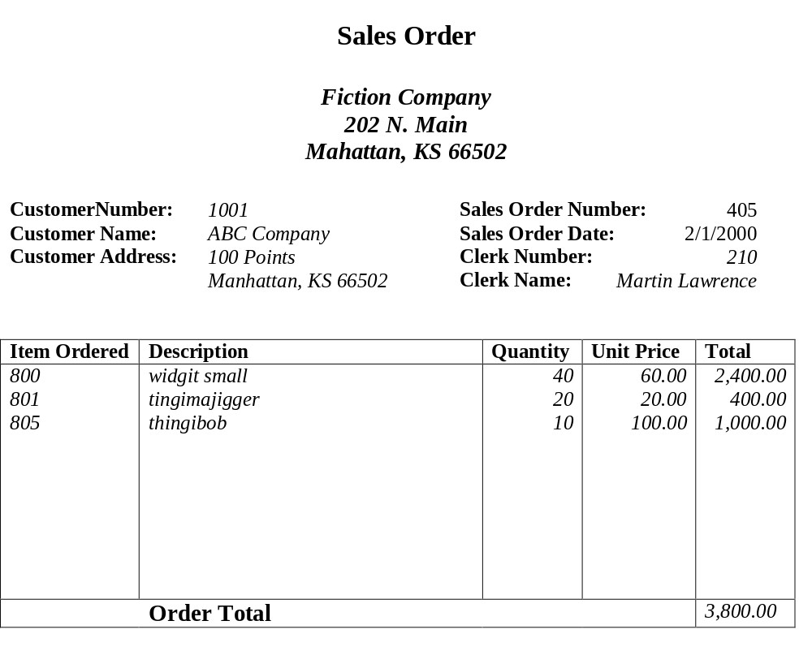
Example1:

Primary Key: Sales Order Number

Example2:
